NAAN MUDHALVAN IBM SKILL

ARTIFICIAL INTELLIGENCE

PHASE 3: DEVELOPMENT

TOPIC:TO CREATE A CHATBOT IN PYTHON

|  |  |  |
| --- | --- | --- |
| Name | NM Id | Email Id |
| K.Kamalika | au820321106020 | kamalikakathiresan2003@gmail.com |
| S.Abirami | au820321106002 | abiramisaravanan1512@gmail.com |
| M.Karpagasri | Au820321106021 | hemalatamohan4@gmail.com |
| S.Subha | au820321106036 | Subhasundaravadivel2004@gmail.com |
| K.S.Avanthiga | au820321106009 | Avanthigakumar2004@gmail.com |

Tech BOT

INTRO ABOUT TECH BOT:

Tech bots can provide real-time customer support and are therefore a valuable asset in many industries. When you understand the basics of the TECH Bot library, you can build and train a self-learning TECH bot with just a few lines of Python code.

To simulate a real-world process that you might go through to create an industry-relevant TECH BOT, you’ll learn how to customize the TECH BOT response .

The TECH BOT library combines language corpora, text processing, machine learning algorithms, and data storage and retrieval to allow you to build flexible TECH BOT.

You can build an industry-specific TECH BOT by training it with relevant data. Additionally, the TECH BOT will remember user responses and continue building its internal graph structure to improve the responses that it can give.

PROGRAM FOR TECH BOT SAMPLE:

Import random

# Define a list of responses

Responses = [

“Hello! How can I help you today?”,

“What’s on your mind?”,

“Tell me more about that.”,

“I’m here to assist you.”,

]

# Function to generate a response

Def Techbot_response(input_text):

Return random.choice(responses)

# Main chat loop

While True:

User_input = input(“You: “)

If user_input.lower() == “exit”:

Print(“Techbot: Goodbye!”)

Break

Response = Techbot_response(user_input)

Print(“Techbot:”, response)

SAMPLE OUTPUT OF PROGRAM:

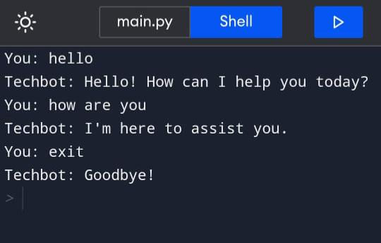

# CONCLUSION:

# In this project, we have introduced a tech bot that is able to interact with users. This tech bot can answer queries in the textual user input.

# users can easily type their query in natural language and retrieve information.